##### Aim:

**EXERCISE 4 – ANDROID APPLICATION TO DRAW BASIC GRAPHICAL PRIMITIVES**

To develop a Simple Android Application that draws basic Graphical Primitives on the screen.

##### Procedure:

**Creating a New project:**

* Open Android Studio and then click on **File -> New -> New project.**

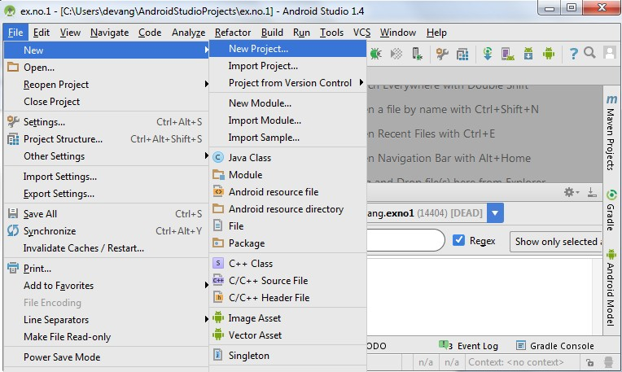

* Then type the Application name as “**ex.no.4″** and click **Next.**

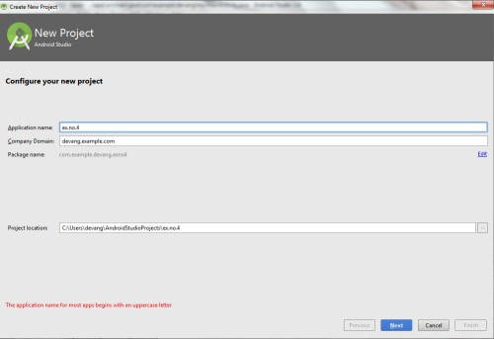

* Then select the **Minimum SDK** as shown below and click **Next**.

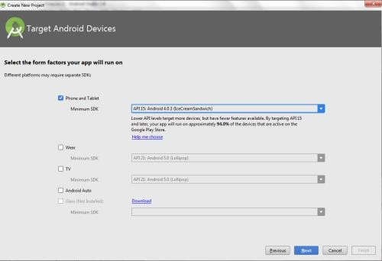

* Then select the **Empty Activity** and click **Next.**

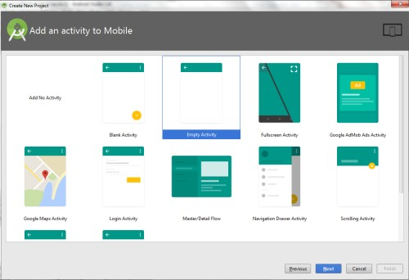

* Finally click F**inish**.

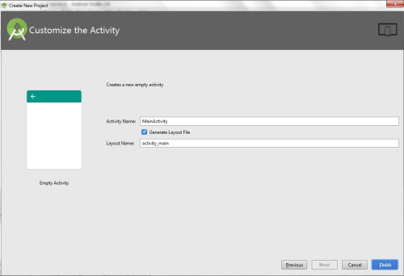

* It will take some time to build and load the project.
* After completion it will look as given below.

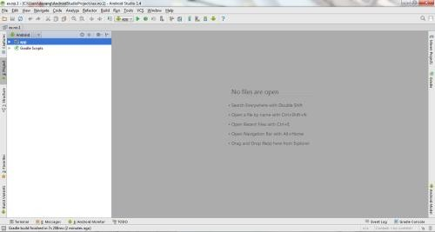

**Designing layout for the Android Application:**

* Click on **app -> res -> layout -> activity_main.xml.**

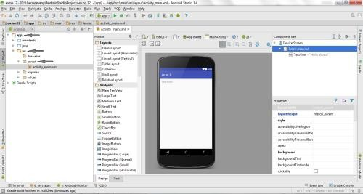

* Now click on **Text** as shown below.

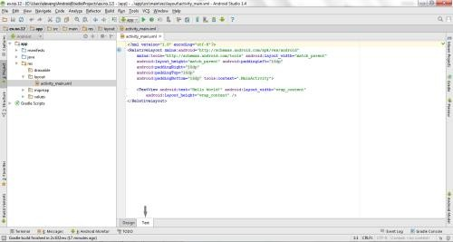

* Then delete the code which is there and type the code as given below.

##### Code for Activity_main.xml:

<?xml version="1.0" encoding="utf-8"?>

<RelativeLayout [xmlns:android="http://schemas.android.com/apk/res/android"](http://schemas.android.com/apk/res/android) android:layout_width="match_parent" android:layout_height="match_parent">

<ImageView

android:layout_width="match_parent" android:layout_height="match_parent" android:id="@+id/imageView" />

</RelativeLayout>

* Now click on **Design** and your application will look as given below.

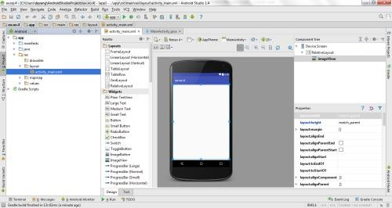

* So now the designing part is completed.

**Java Coding for the Android Application:**

* Click on **app -> java -> com.example.exno4 -> MainActivity.**

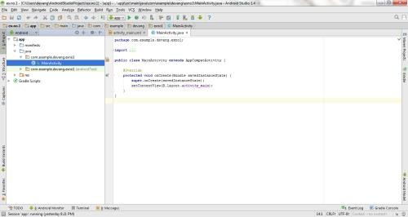

* Then delete the code which is there and type the code as given below.

##### Code for MainActivity.java:

package com.example.exno4;

import android.app.Activity; import android.graphics.Bitmap; import android.graphics.Canvas; import android.graphics.Color; import android.graphics.Paint;

import android.graphics.drawable.BitmapDrawable; import android.os.Bundle;

import android.widget.ImageView;

public class MainActivity extends Activity

{

@Override

public void onCreate(Bundle savedInstanceState)

{

super.onCreate(savedInstanceState); setContentView(R.layout.activity_main);

//Creating a Bitmap

Bitmap bg = Bitmap.createBitmap(720, 1280, Bitmap.Config.ARGB_8888);

//Setting the Bitmap as background for the ImageView ImageView i = (ImageView) findViewById(R.id.imageView); i.setBackgroundDrawable(new BitmapDrawable(bg));

//Creating the Canvas Object Canvas canvas = new Canvas(bg);

//Creating the Paint Object and set its color & TextSize Paint paint = new Paint();

paint.setColor(Color.BLUE); paint.setTextSize(50);

//To draw a Rectangle canvas.drawText("Rectangle", 420, 150, paint);

canvas.drawRect(400, 200, 650, 700, paint);

//To draw a Circle canvas.drawText("Circle", 120, 150, paint);

canvas.drawCircle(200, 350, 150, paint);

//To draw a Square canvas.drawText("Square", 120, 800, paint);

canvas.drawRect(50, 850, 350, 1150, paint);

//To draw a Line

canvas.drawText("Line", 480, 800, paint);

canvas.drawLine(520, 850, 520, 1150, paint);

}

}

* So now the Coding part is also completed.
* Now run the application to see the output.

##### Output:

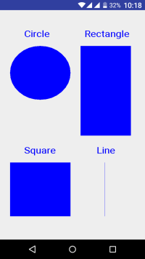

##### Result:

Thus a Simple Android Application that draws basic Graphical Primitives on the screen is developed and executed successfully.

##### EXERCISE 4.1:

Execute the above exercise of graphics in Android studio and show the exact GUI output? [2]

##### TASK 4.1

Develop an android application to display simple graphics i.e. Oval, Rectangle with different colors.

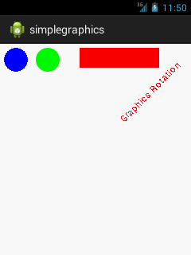

##### EXERCISE 4.2:

Develop an android application to display two fragments. [8]

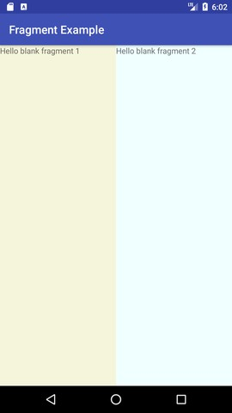

##### RESOURCES:

<https://www.codingconnect.net/mobile-application-development-lab/> <https://www.javatpoint.com/android-tutorial> <https://www.tutorialspoint.com/android> <https://developer.android.com/guide> [Https://developer.Android.com/training/basics/firstapp/creating-project](https://developer.android.com/training/basics/firstapp/creating-project)

[Https://www.raywenderlich.com/120177/beginning-Android-development-tutorial-](https://www.raywenderlich.com/120177/beginning-Android-development-tutorial-installingAndroid-studio) [installingAndroid-studio](https://www.raywenderlich.com/120177/beginning-Android-development-tutorial-installingAndroid-studio) <https://www.youtube.com/playlist?list=PLS1QulWo1RIbb1cYyzZpLFCKvdYV_yJ-E> [Https://www.udemy.com/java-tutorial/](https://www.udemy.com/java-tutorial/)

[Https://www.w3schools.com/xml/](https://www.w3schools.com/xml/) [Http://www.Androidguys.com/](http://www.androidguys.com/)